Ground State of Excitons, Charged Excitons and Biexcitons in Double Quantum Well Structure with Spatial Separation of Carriers
RA Sergeev, RA Suris
A.F. Ioffe Physical-Technical Institute RAS, Saint Petersburg
e-mail: rinat@theory.ioffe.rssi.ru
The ground states of the exciton, the X–, X⁺ trions and the biexciton in the system of two quantum wells with the spatial separation of the electrons and the holes are studied theoretically. The simple vivid trial functions for the binding energy calculations of such spatially-indirect excitonic complexes are proposed. The qualitative structure of the complexes in such a system is discussed. For the trions and the biexciton the critical values of the distance between the wells, where the corresponding complex becomes unbound, are estimated. The mass ratio dependence of the binding energy of these complexes is analyzed.
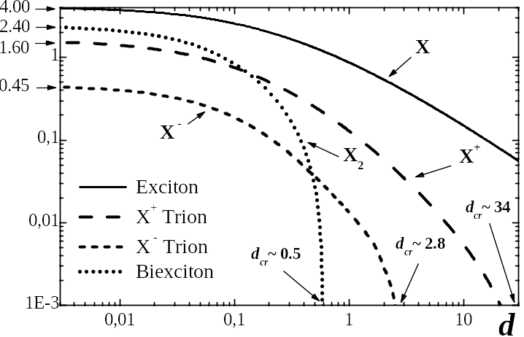
For the calculations the simple model of two ideal two-dimensional quantum wells is used. The hole is taken to be much heavier than the electron and the dependence of the binding energy on the mass ratio is introduced in frames of the adiabatic approximation. The calculated binding energy dependencies on the distance between the wells for the exciton, the X–, X⁺ trions and the biexciton are shown on the figure.
Fig.1. The binding energy of the excitonic complexes versus the distance between the wells.
The bulk excitonic units are used for the energy and the distance. The electron-to-hole mass ratio is taken to be zero.
The work is supported by Russian Foundation for Basic Research, grant 05-02-16679 and Federal Program on Support of Leading Scientific Schools.

References
[1] R.A. Sergeev, R.A. Suris, NATO Science Series II 119, 279 (2003)
[2] R.A. Sergeev, R.A. Suris, Semiconductors 37, 1205 (2003)

