Numerical analysis of threshold polariton phenomena in a microcavity
N.A. Gippius, S.S. Gavrilov*, V.D. Kulakovskii* and S.G. Tikhodeev
General Physics Institute, RAS, Moscow
* Institute of Solid State Physics, RAS, Chernogolovka
e-mail: tikh@gpi.ru
In order to investigate the way of a self-organization in a pumped exciton-polariton system [see “Polariton scattering and threshold phenomena in a microcavity”, N.A. Gippius, S.S. Gavrilov, V.D. Kulakovskii and S.G. Tikhodeev], we solve numerically the system of coupled equations [1] for the exciton polarization and quantum well (QW) electric field in a microcavity, accounting for an external pumping and a contact exciton-exciton interaction process.
The figure illustrates the calculated angular (panels a,b,c, logarithmic scale) and spatial (panel d, linear scale) distributions of electromagnetic field intensity in the QW. Three different stages of the system evolution are presented: (a) weak scattering before developing a parametric instability; (b) breaking up the unperturbed solution; (c) appearance of several macro-occupied states. A typical instantaneous spatial distribution on the third stage is shown in panel (d).
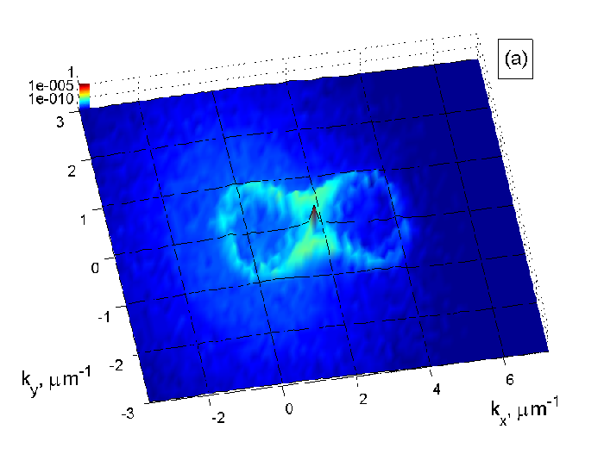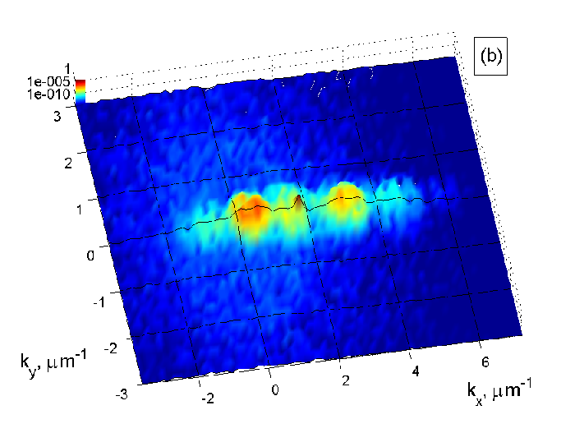

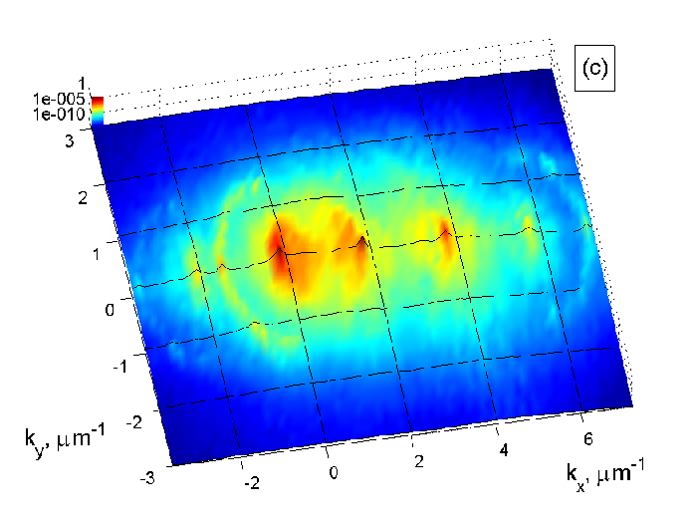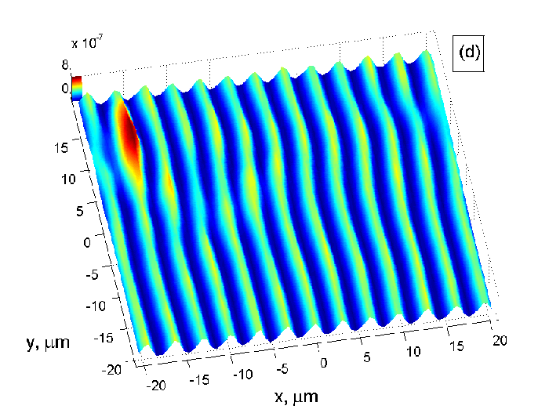

References
[1] N.A. Gippius et al, J.Phys.-Condensed Matter 16, S3653-3664 (2004)

