Tuning of the exciton potential landscape in GaAs/AlGaAs quantum wells and correlation between optical properties and interface morphology

N. Moret, D. Y. Oberli, E. Pelucchi, N. Gogneau, A. Rudra and E. Kapon
Ecole Polytechnique Fédérale de Lausanne (EPFL)
Laboratory of Physics of Nanostructures
CH-1015 Lausanne, Switzerland

e-mail: Nicolas.moret@epfl.ch

Well-controlled engineering of the potential landscape confining excitons is a primary condition for investigations of semiconductor heterostructures. In this context, the focus of interest can be either in the homogeneity of this potential, for example for optical device applications, or in its disorder, as it is the case for exciton localization or condensation. In this work, we show that major modifications of the exciton confinement in GaAs/AlGaAs quantum wells (QW) can be obtained when growing on substrates with a small miscut by metallorganic vapor phase epitaxy (MOVPE). The various growth modes obtained on substrates that are slightly misoriented off the-(100) direction can be evidenced by atomic force microscopy (AFM) and can be clearly correlated with the photoluminescence (PL) spectra [1]. Both PL energy and linewidth are consistent with the confinement potential deduced from the interface images.
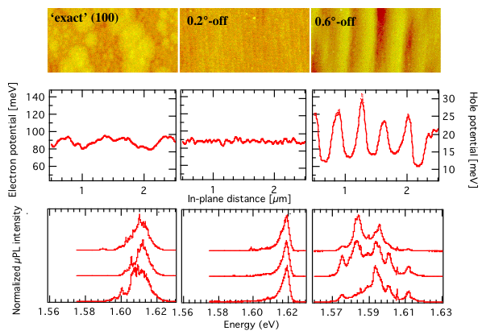
Structures grown on almost exactly (100)-oriented substrates localize excitons on monoatomic islands forming at the QW interfaces. Intermediate misorientations (in the 0.6°-1.5° range) induce step-bunched interfaces producing large fluctuations of the QW width and several extended potential minima. A much smoother potential is obtained when growing on slightly misoriented substrates (0.2°-off (100)) since, in that case, narrow atomically smooth terraces appear and arrange periodically at each interface. As a result the PL linewidth is strongly reduced and emission from excitonic complexes can be resolved. For larger misorientations (≥2°) excitons are again localized. For given growth conditions, there is thus a very specific misorientation range in which optimal PL linewidth can be obtained.
This study elucidates part of the relations between interfaces morphology and PL properties, by showing the excellent correlation between the confinement potentials inferred from the two different methods.
Fig.1: (top) 1x2µm² AFM images of GaAs interfaces for 3 different substrate misorientations, and typical carrier potentials inferred from AFM images (middle) along with µPL spectra taken at different positions (bottom)

[1] N. Moret, D.Y. Oberli, E. Pelucchi, N. Gogneau, A. Rudra and E. Kapon, APL 88, 141917 (2006)

