The specular reflection of light from a photonic crystal enhanced by the diffraction and internal reflection
A.N. Poddubny
A.F.Ioffe Physico-Technical Institute, St. Petersburg
e-mail: poddubny@coherent.ioffe.ru
Periodic structures where the dielectric susceptibility of one of the compositional materials has a pole at a certain resonance frequency form a special class of Resonant Photonic Crystals (RPC). If the resonance is of an excitonic nature then the normal light waves propagating in such a system are excitonic polaritons. In the present work we have theoretically studied the exciton-polariton dispersion as well as specular reflection and diffraction spectra from a two-dimensional (2D) RPC. The structure under consideration is a periodic quadratic array of cylinders grown of the material A with the dielectric function ε_{A}(ω,q) = ε_{a} {1 + ω_{LT}/[ω₀ + ħq²/(2M) – ω ]} embedded into a matrix B with the dielectric constant ε_{B}. Both time dispersion and spatial dispersion of ε_{A} have been taken into account. We have restricted ourselves to the case of normal light incidence and TE polarization, when the exciton polaritons propagate perpendicularly to the cylinder axes and are polarized along these axes.
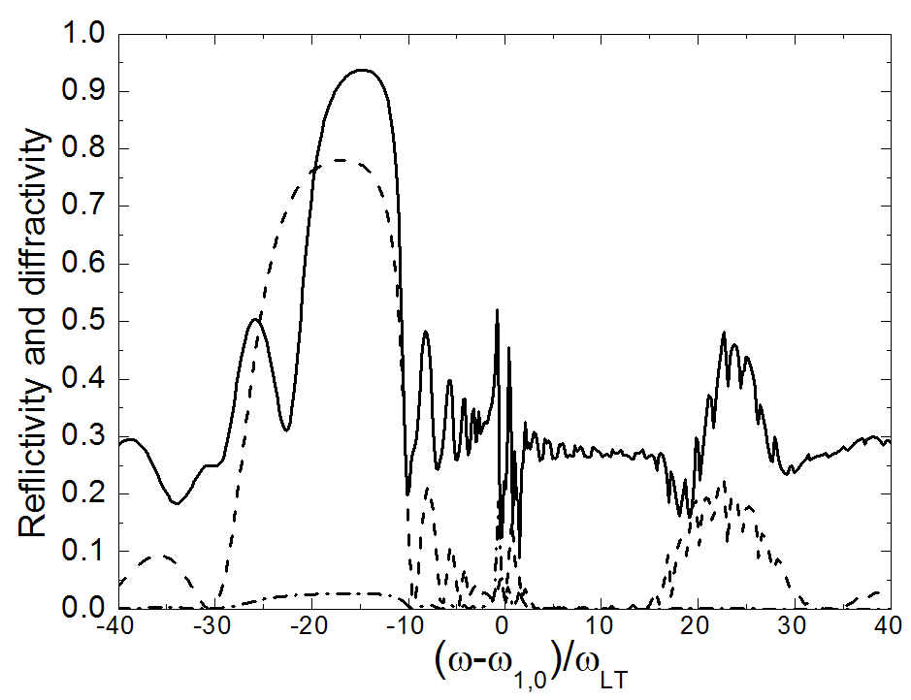
The calculation has been performed by the 2D version of the Korringa-Kohn-Rostocker method previously applied to the three-dimensional RPC[1]. Figure presents the calculated optical spectra of the 2D RPC. The following set of parameters has been used: R/a=0.35, ε_{a}=11, ε_{B}=10, ω_{LT}/(ω_{1,0} – ω₀)=15.7, ω_{1,0}a/c=0.76, ω_{LT}/ω_{1,0}=5×10⁻⁴, R is the cylinder radius, a is the 2D lattice constant, ω_{1,0} is the resonant frequency of the ground exciton state confined in the single cylinder. Dot-dashed and dotted curves depict, respectively, normal reflection and first order diffraction spectra under the light incidence from semi-infinite layer B upon the RPC containing 32 cylinder layers. Solid curve shows the reflection spectrum under the normal incidence from vacuum on the structure with the vacuum – material B interface shifted by a/2 with respect to the centers of the leftmost cylinders A.
Comparison between the dash-dotted and solid curves shows an enhancement of specular reflection under incidence from vacuum as compared to that from the material B. This can be understood that the reflection between the medium B and the RPC is much weaker then the first-order diffraction, cf. the dashed and dash-dotted curves. Under incidence from vacuum the light transmitted into the RPC is first diffracted, then exhibits total internal reflection from vacuum - B interface, the next diffraction into the normal direction and finally outgoes into vacuum as a normally reflected wave. This results in an enhancement of the reflectivity seen in Figure.

References
[1] E.L. Ivchenko and A.N. Poddubny, Phys. Solid State 48 540(2006).

