Experimental Observation of Transition from 2D to 3D Quantum Confinement in Semiconductor Quantum Wires/Quantum Dots
Q. Zhu, E. Pelucchi, K. F. Karlsson, S. Dalessi, Marc-André Dupertuis and E. Kapon
Ecole Polytechnique Fédérale de Lausanne (EPFL), Laboratory of Physics of Nanostructures, CH-1015 Lausanne, Switzerland
e-mail : qing.zhu@epfl.ch
Self-limited growth of Al_{x}Ga_{1-x}As alloys by metallorganic vapor phase epitaxy in inverted pyramidal recesses etched on (111)B GaAs substrates leads to the formation of complex nanostructures. Capillarity-driven Ga-Al segregation yields vertical quantum wires (VQWRs) at the center of the pyramid, connected to more-weakly segregated vertical quantum wells (VQWs) formed along their wedges (see inset of Fig. 1)[1]. We show here that not only these nanostructures can be used for constructing wires with controlled potential variations along their axis but also for systematic studies of the transition between 2D and 3D quantum confinement.
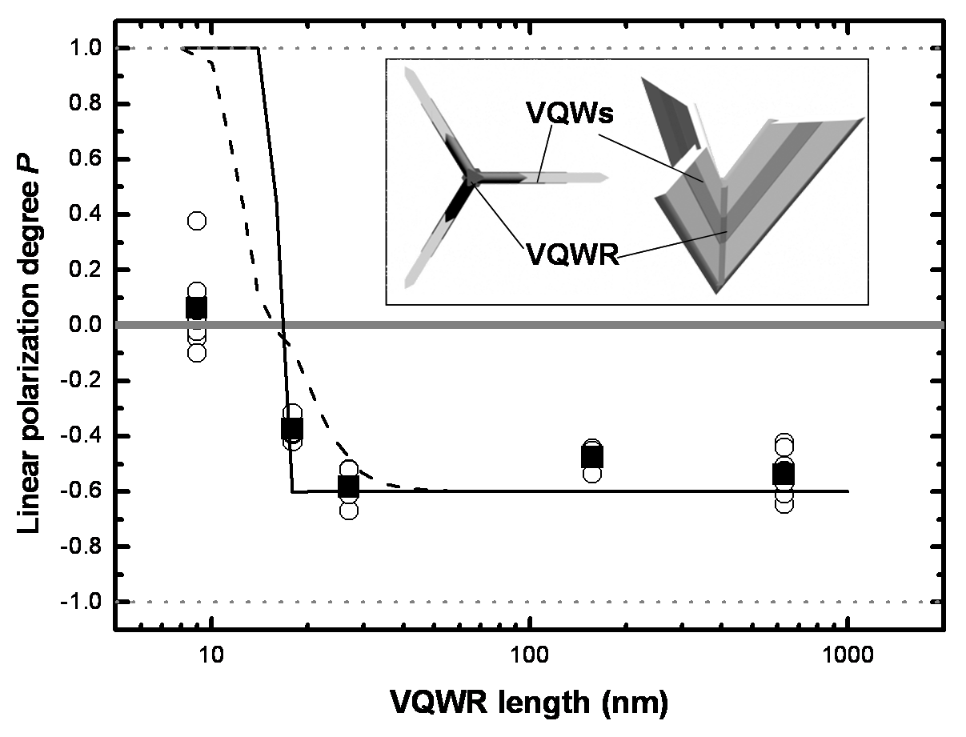
The 2D nature of the quantum confinement in our quantum wires was confirmed by micro-PL spectra in which several transitions between quantum– confined electron and hole states are identified [1]. We further explored the boundaries between quantum wire and quantum dot (QD) behavior by simply shortening the length of the VQWR until signatures of 3D quantum confinement appear. We observed several typical QD spectral features: 1) higher confinement energies of the ground states; 2) narrower photoluminescence peaks; 3) larger separation between ground and excited transitions.
Fig. 1. (main) Linear polarization degree of the emission as a function of wire length; (inset) Sketch of the hetero-structures inside the pyramids.
Moreover, the observed polarization anisotropy of the VQWR emission depends on the wire length, in accordance with model calculations accounting for valence band mixing. In figure 1, the black squares represent the measured average linear polarization degree P of the VQWR ground emission. P=1 and P=-1 represent emission completely polarized perpendicular and along the wire axis, respectively. The calculated polarization degree of the ground state alone is indicated by the solid line in Fig.1, while a peak broadening (FWHM=3meV, several nearby transition) is taken into account for the dashed line. Clearly we see the trend of increased value of P when wire shortened, eventually with a change of sign after entering the QD regime.
A particularly attractive feature of these wires (and dots) is the possibility to modify their composition and /or structure along their axis with monolayer accuracy, by simply tuning the growth parameters. This brings an interesting application of constructing new class of QWRs and related low dimensional nanostructures, including tapered wires, wire-connected QD molecules and QD superlattices.

References
[1] Q. Zhu et al, Nano Letters, 6, 1036 (2006)

