Effect of magnetic field on polariton-electron scattering in semiconductor microcavities
V.V. Belykh and V.A. Tsvetkov
P.N. Lebedev Physical Institute, Russian Academy of Sciences, Moscow, Russia
e-mail: belykh@sci.lebedev.ru
Microcavity polaritons are quasiparticles resulting from coupling of excitons in quantum wells with photons in a microcavity [1]. They have bosonic nature and exhibit very steep dispersion at small wave vectors. These properties predict the possibility of Bose condensation of microcavity polaritons at the bottom of the lower polariton dispersion branch and creation of thresholdless “polariton laser”. But polariton Bose condensation was not achieved under nonresonant optical excitation in GaAs based structures due to the small polariton lifetime at the bottom of the lower polariton branch as compared to the polariton energy relaxation time (the so-called bottleneck effect).
It was suggested that one of the most effective relaxation mechanisms of microcavity polaritons is scattering by free electrons [2]. In the present study it is shown that the contribution from polariton-electron scattering could be separated out from the other polariton relaxation mechanisms by a magnetic field applied perpendicular to the microcavity plane [3]. To demonstrate this, we calculated the polariton population at the bottom of the lower polariton branch as a function of the applied magnetic field. The polariton distribution above the bottleneck region was assumed to be equilibrium. Born approximation was used to calculate the polariton-electron scattering amplitude, and magnetic length was assumed large as compared to the exciton Bohr radius.
It is shown that the population dependence on the magnetic field has an oscillatory behavior (Fig. 1). Oscillations result from discrete energy spectrum of quantum well electrons in magnetic field and peculiar only to the polariton-electron (hole) scattering (in contrast to the polariton-phonon and polariton-exciton scattering).
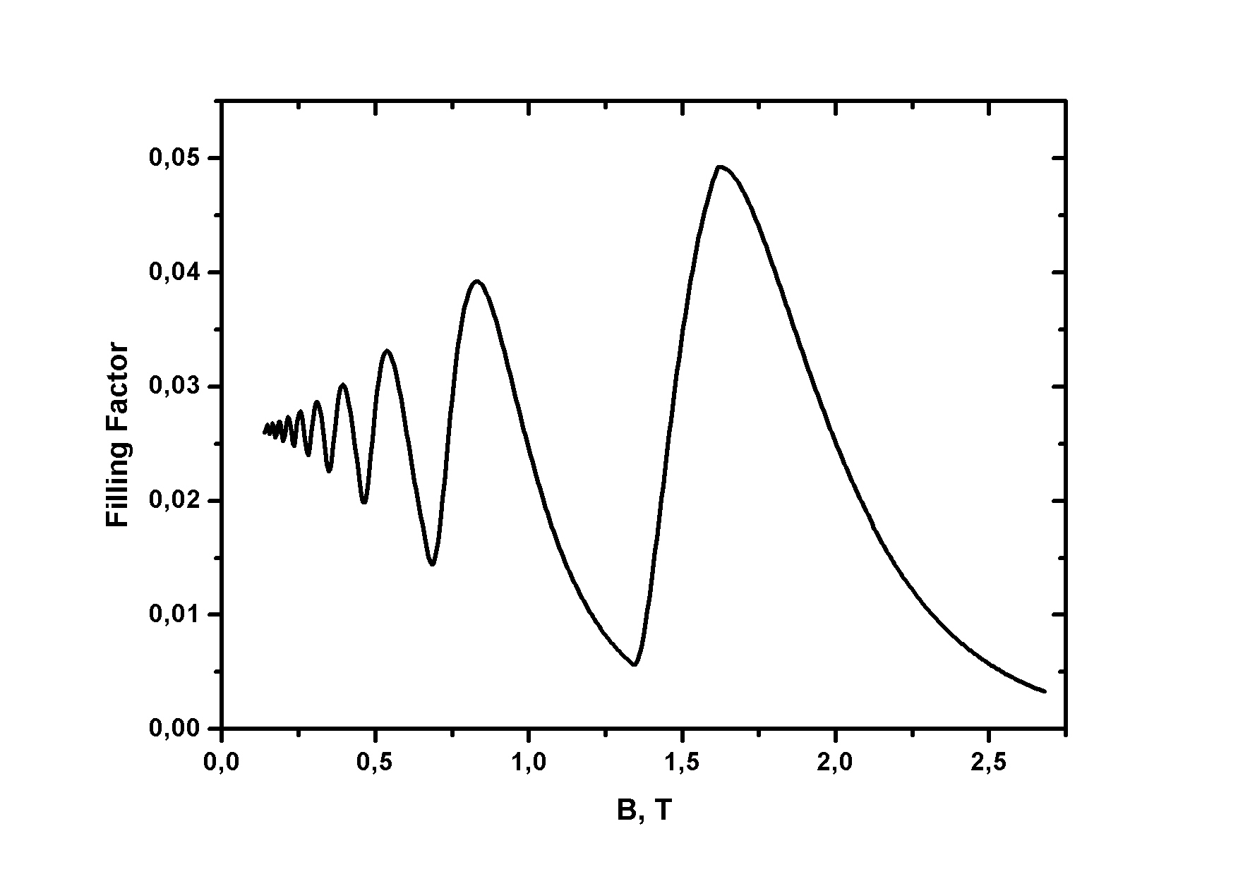
Preliminary experimental data on studying polariton relaxation in magnetic field under nonresonant optical excitation is also presented. It shows that polariton-electron scattering becomes significant only at high levels of excitation (close to the transition to the weak coupling regime) and does not govern the polariton relaxation at intermediate excitation levels at low temperatures (lower than 4 K).
The study was supported by the Russian Foundation for Basic Research (project no. 05-02-17328) and INTAS (project no. 01-0832).
Fig .1. Magnetic field dependence of the polariton filling factor at the bottom of the lower polariton branch. The temperature is 4 K, polariton branch depth is 2 meV.

Refrences:
[1] C.Weisbuch, M.Nishioka, A.Ishikawa, et al., Phys. Rev. Lett. 69, 3314 (1992).
[2] G.Malpuech, A.Kavokin, A.Di Carlo, et al., Phys. Rev. B 65, 153310 (2002).
[3] V.V. Belykh, Zh.Exp.Teor.Fiz. (to be published)

