Single Quantum Dots for telecom applicatios
C. Zinoni¹, B. Alloing¹, C. Monat¹, L. H. Li¹, L. Lunghi², A. Gerardino² and A. Fiore¹
¹ Ecole Polytechnique Fédérale de Lausanne (EPFL), CH-1015 Lausanne, Switzerland
²Institute of Photonics and Nanotechnology, CNR, Roma, Italy
e-mail: carl.zinoni@epfl.ch
Efficient generation of single photons at telecom wavelength (1310nm and 1550nm) on request is crucial for quantum key distribution (QKD). The optical properties of single quantum dots (QDs) have the potential for satisfying the requirements of a convenient single photon source: QDs can be grown in conventional semiconductor epitaxial systems and the nature of the 3D confinement of the wavefunction generates atomic-like spectral features. We have grown self assembled InAs/GaAs quantum dots embedded in a planar microcavity with an average spatial density of 1dot/μmP^{-2P}. By means of metallic apertures or etched mesas with ≈1 μm-diameter it was possible to isolate a single QD. Photoluminescence measurements on single QDs reveal spectral lines at 1300nm characterized by a FWHM of 40μeV, which are attributed to exciton, biexciton and charged exciton transitions in the ground state. The identification of the spectral lines is further supported by lifetime measurements, to our knowledge, the first ever to have been made at these wavelength. We demonstrate that our single QDs are efficient sources of triggered single photons coupled to O-band single mode fibers. The experimental value of second-order correlation function, g(2)(0)=0.38, demonstrates strong suppression of multi-photon pulses per excitation cycle. By tuning the InGaAs APDs we are able to measure the second order correlation function with integration times comparable to those made in the region of the spectrum where silicon technology is used. To reduce the emission of uncorrelated photons we pump in the excited states of the QD with a tunable laser, preliminary data will be presented. Implementation of a single photon source in a practical QKD system requires operating under electrical pumping. We investigated two techniques for obtaining a single quantum dot LED: the first approach exploits narrow metal apertures to select spatially the emission from a few QDs. In the second approach, sub-micrometer oxidized current apertures have been realized within LED structures. Low temperature electroluminescence measurements show narrow spectral lines (line width <200 μeV) which can be attributed to emission from single QDs.
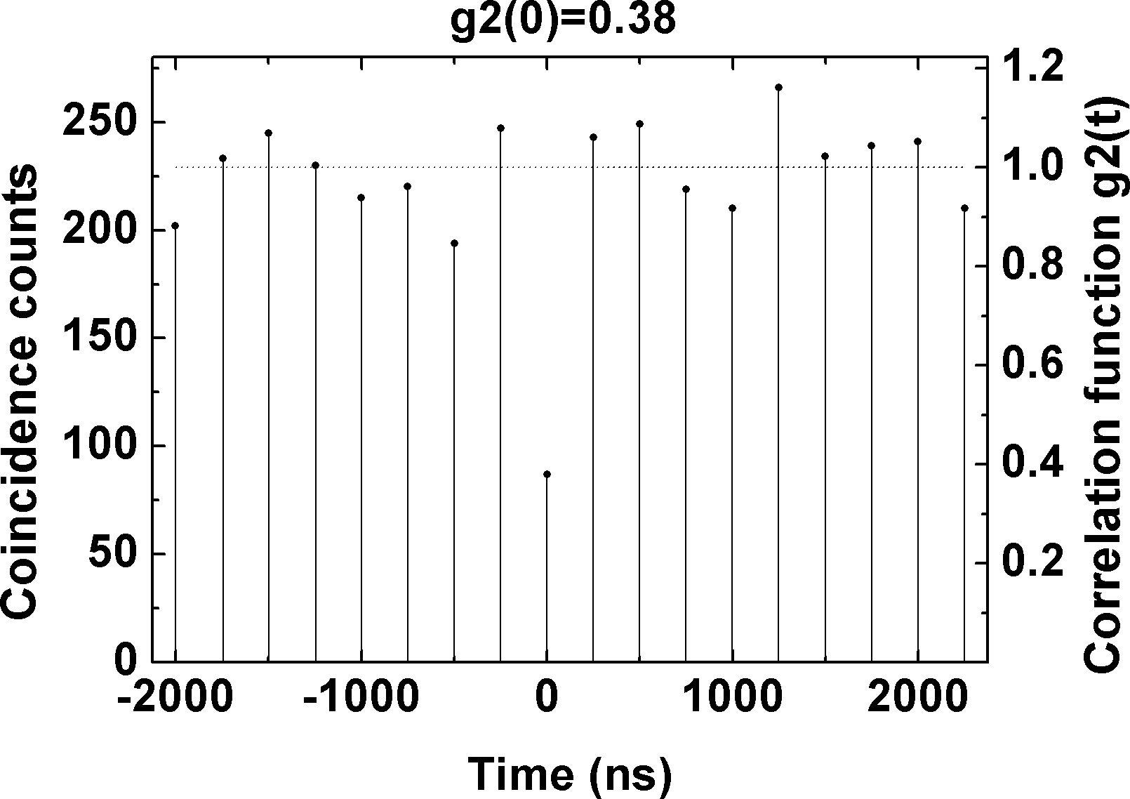
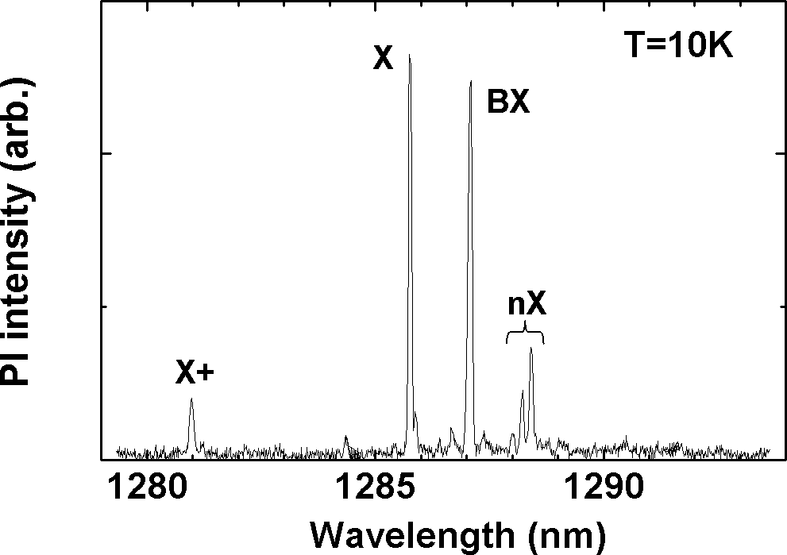
Fig.2: Second order correlation function for a single exciton line.

Fig.1: Photoluminescence of a single QD.

