Condensation of excitons in strained Si_{1-x}Ge_{x} layers
of silicon nanostructures
E.A. Bobrik, T.M. Burbaev, V.A. Kurbatov, M.M. Rzaev, N.N. Sibeldin,
V.A. Tsvetkov, and F. Schäffler*
P.N. Lebedev Physical Institute, RAS, 119991 Moscow, Russia
*Institut für Halbleiter- und Festkörperphysik, J.Kepler Universität Linz, Austria
e-mail: burbaev@sci.lebedev.ru
Si/Si_{1-x}Ge_{x}/Si structures with various thicknesses of strained SiGe layers and various content of germanium (x) in layers have been grown by MBE in J. Kepler University, Linz (Austria). Investigations of the photoluminescence (PL) spectra in the temperature region of 2-50 K and with the level of excitation varying from 2 W/cm² to 200 W/cm² have been made at P.N. Lebedev Physical Institute (Russia).
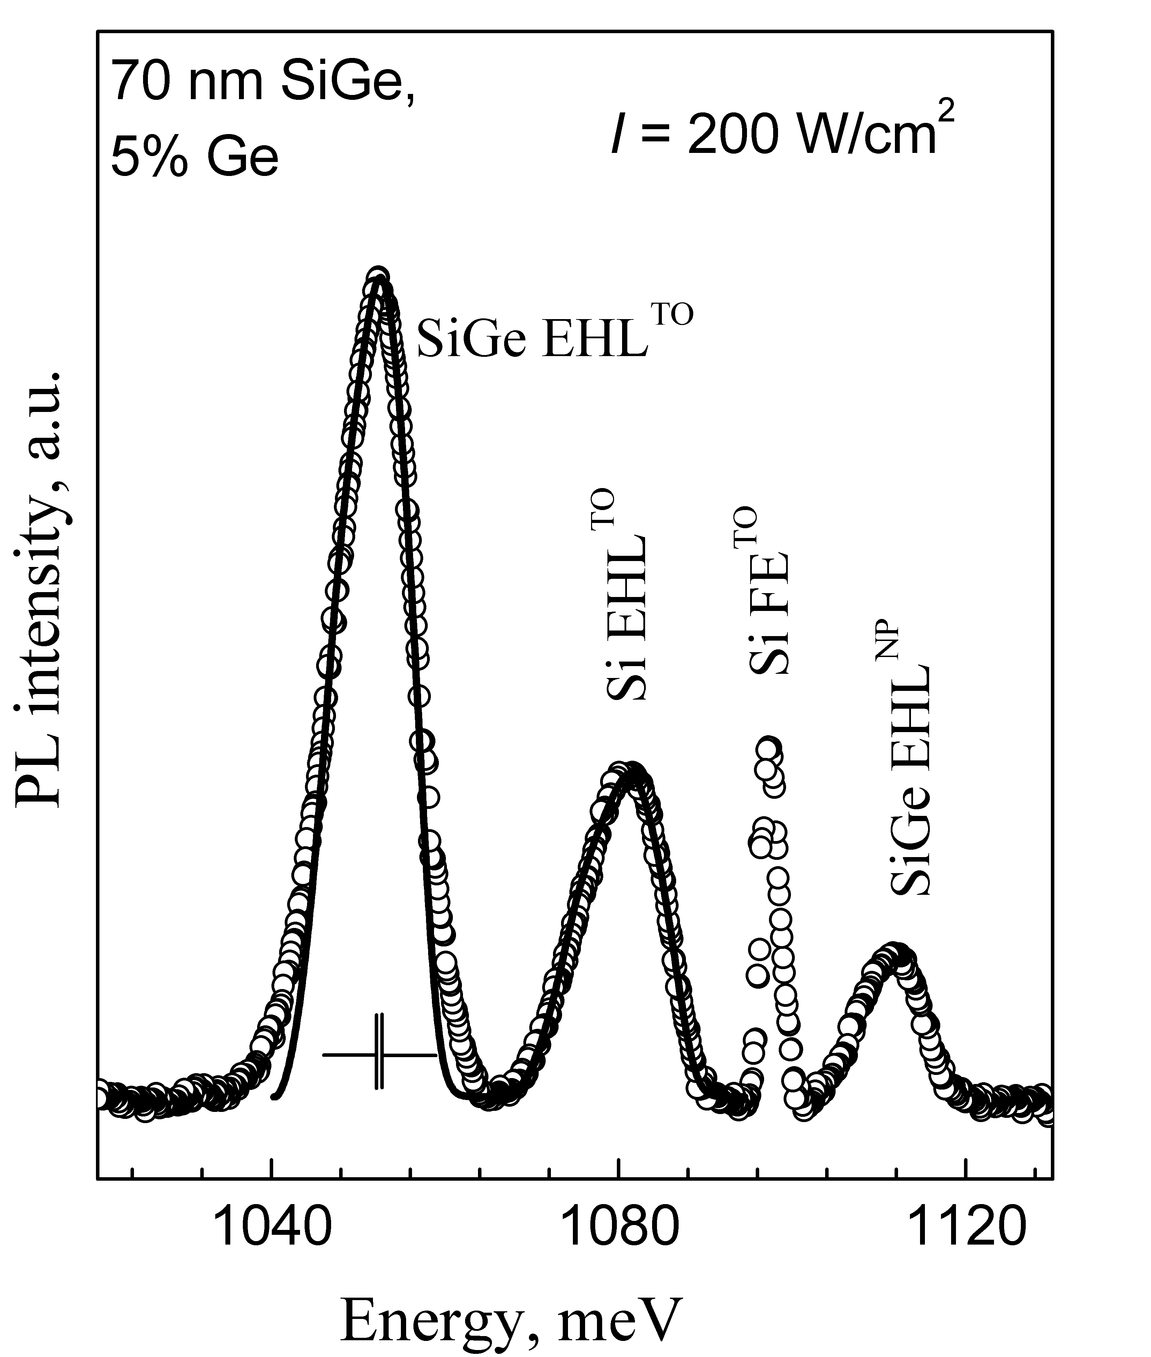
The formation of electron-hole liquid (EHL) in the layer of solid solution and also in the buffer and the cap layers of silicon were detected at helium temperatures. It is shown that owing to accumulation of the photoexcited charge carriers in the potential well of the structure (in the SiGe layer), the EHL in this layer forms at a lower level of excitation of the structure (at the given temperature) and at a higher temperature (at the given level of excitation), than in bulk material of the same composition. The analysis of the form of luminescence lines allows us to estimate the EHL density (n₀) and the binding energy with respect to gas of excitons (ϕ). In figure the example of theoretical treatment of the form of the EHL luminescence line with use of three-dimensional combined density of states for electrons and holes is shown for
Si/Si_{1-x}Ge_{x}/Si nanostructure with thickness of SiGe layer of 70 nm (solid lines). The values of the binding energy and the density of the EHL calculated as a result of such treatment appeared equal: ϕ = 5.2 meV, n₀ = 2.6 ⋅10¹⁸ см⁻³ for the SiGe layer;ϕ = 8.6 meV, n₀ = 3.3 ⋅10¹⁸ см⁻³ for the Si layers. (The temperature of measurements was equal 6 K). The similar treatment of experimental spectra has been carried out for comparison in bulk SiGe monocrystals
(ϕ = 8.3 meV, n₀ =3.5·10¹⁸ см⁻³). Thus the value n₀ is appreciably lower for EHL in a solid solution layer of a nanostructure than in bulk SiGe alloy of the same composition. The density and the binding energy of EHL in buffer and cap layers of silicon practically do not differ from bulk silicon. A decrease in the density and the binding energy of the EHL in comparison with its value in bulk alloy apparently is caused by the internal strain of the SiGe layer of the heterostructure.
At a high level of excitation and temperature exceeding 30 K the radiation of electron-hole plasma (EHP) in SiGe layer is observed. The EHP radiation has shorter wavelength, than wavelength of the EHL radiation. Unlike the EHL where the n₀ does not depend on a level of excitation, the EHP density decreases with reduction in a level of excitation at constant temperature.
We are grateful to N.V. Abrosimov for fabrication of bulk Si_{1-x}Ge_{x} samples. This work has been supported in part by the RFBR (project 05-02-17328), by the Programs of the RAS, and by the INTAS (project 03-51-5015).

